File link: - https://github.com/talebulislam/SSIS

**Set - C**

**By**

**Amanpreet Kaur Ma’am**

**Name :- Talebul Islam**

**Reg No :- 11904195**

**CA :- 03**





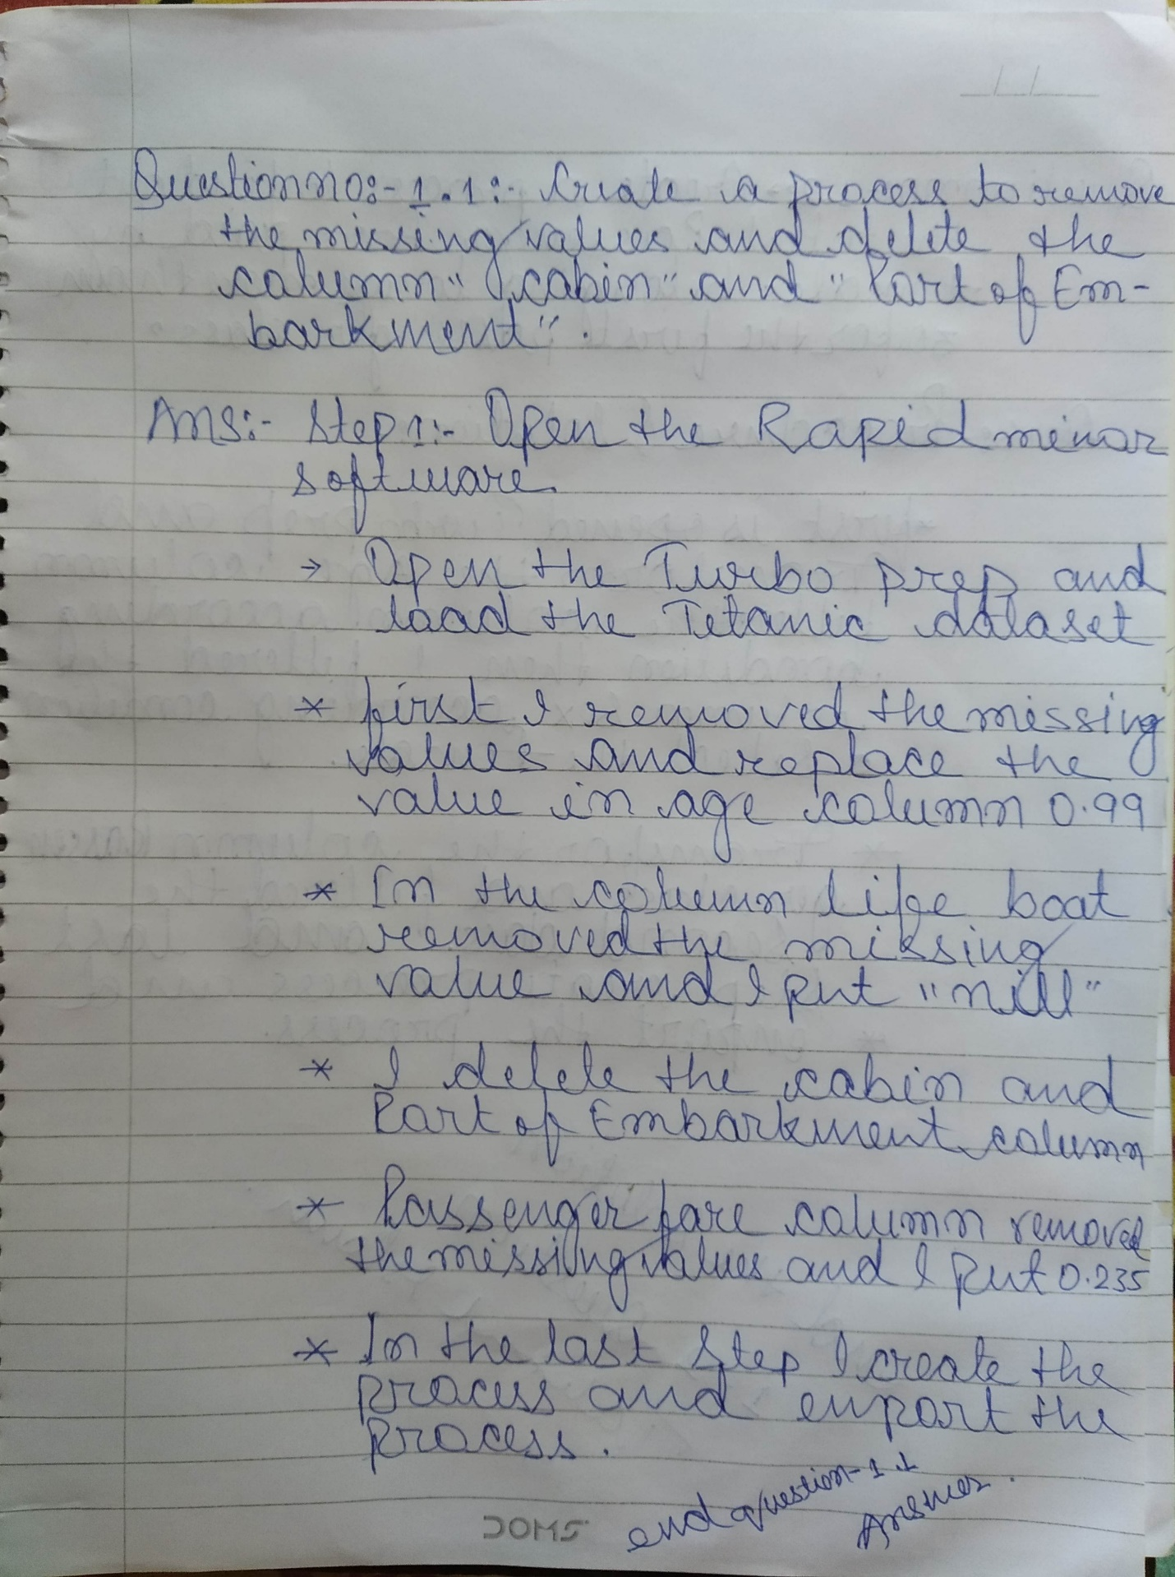

Q1) Using TITANIC DATASET(available in SAMPLES folder of rapid miner repository) perform the following questions

1. Remove Missing values from life Age and I putt value “0.99”

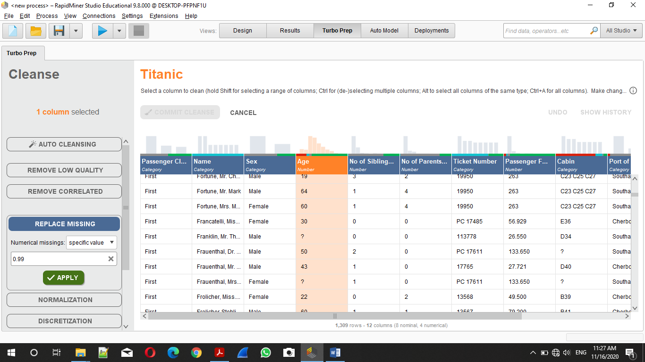

1. Remove Missing values from life Boat and I putt value “Nill”

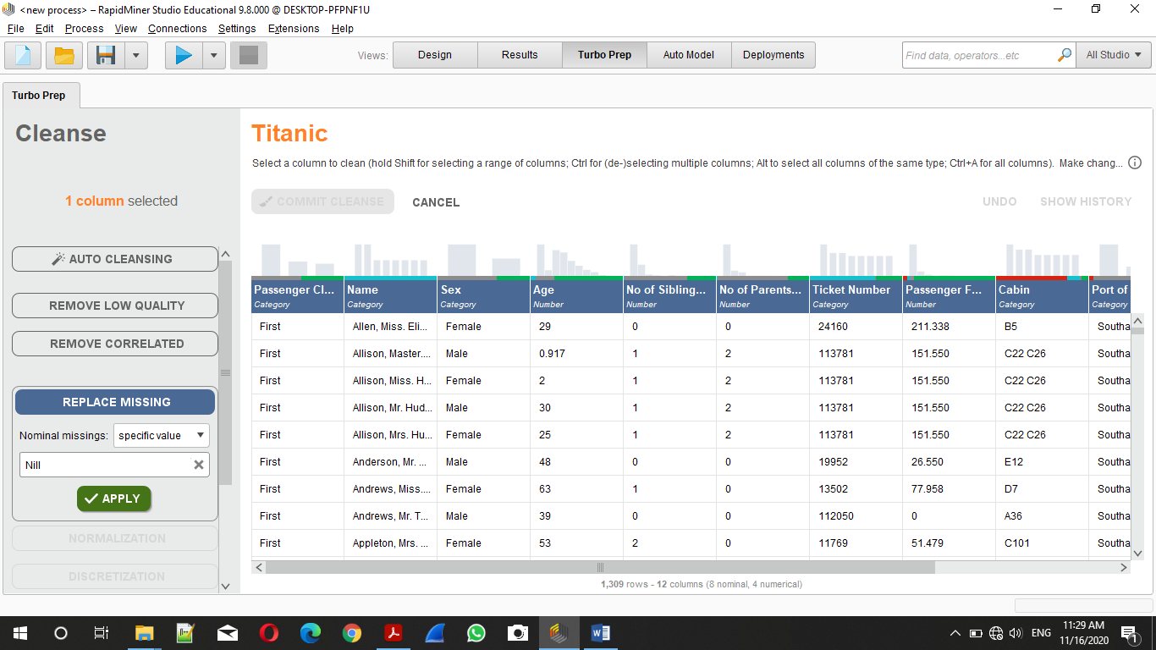

1. Remove Missing values from Passenger Fare and I putt value “ 0.235 ”

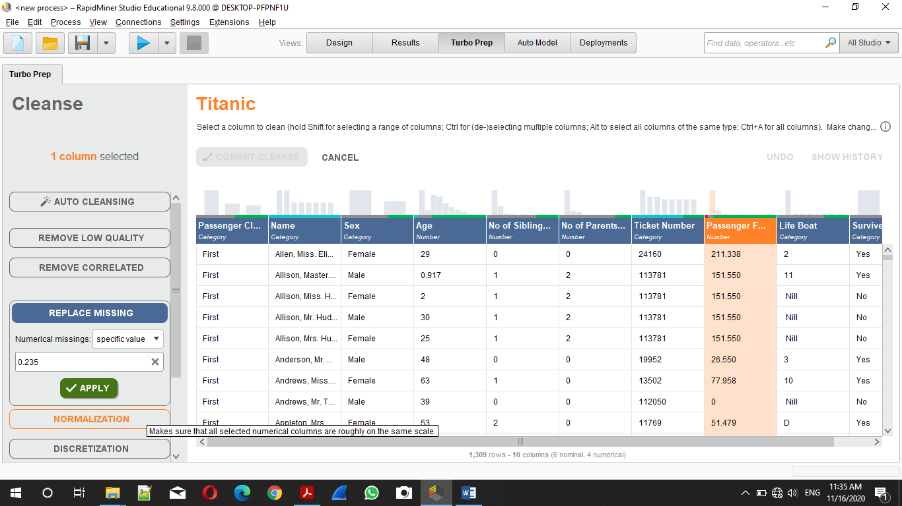

1. Remove (Delete) Column “ Cabin ”.

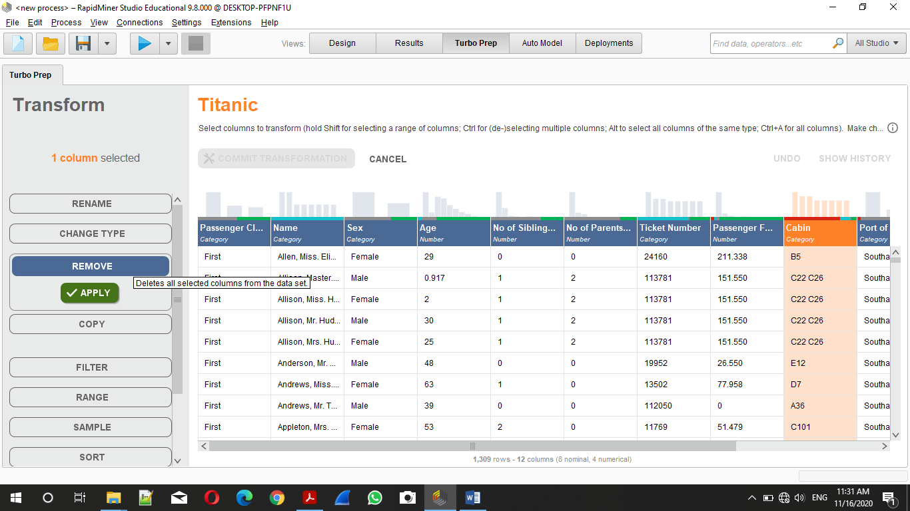

1. Remove (Delete) Column “ Port of Embarkment ”.

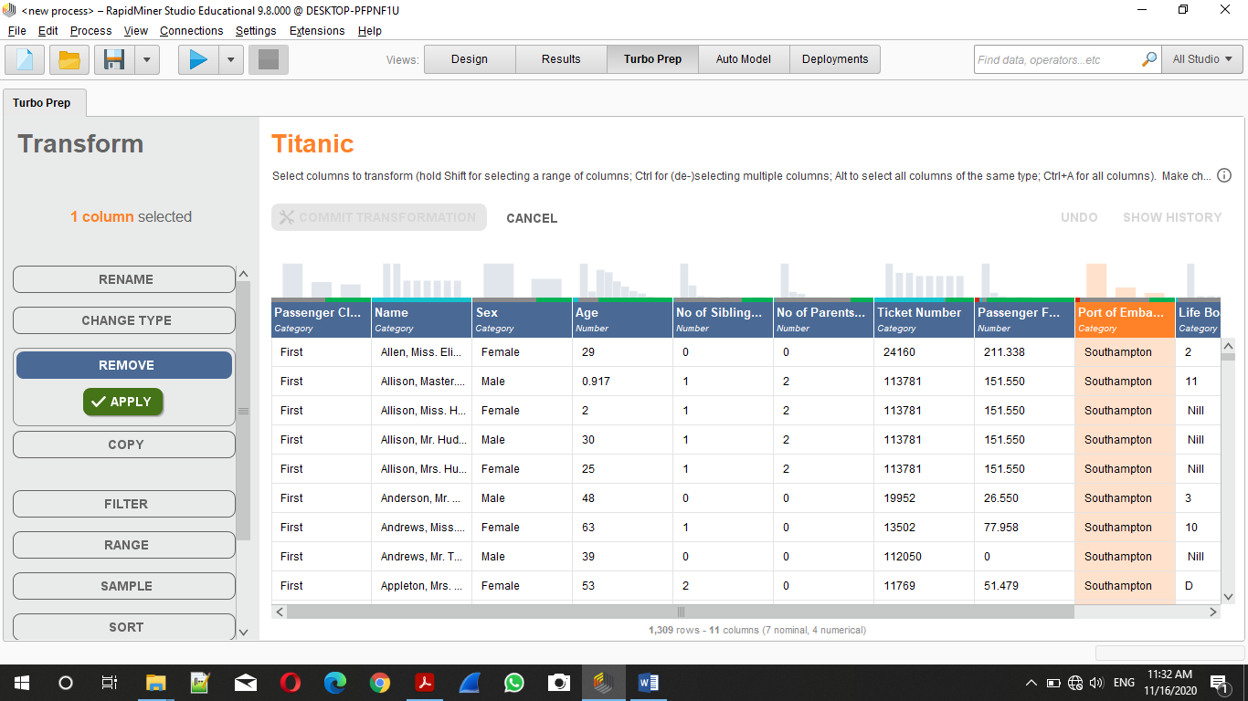

1. Final Output Result Window.

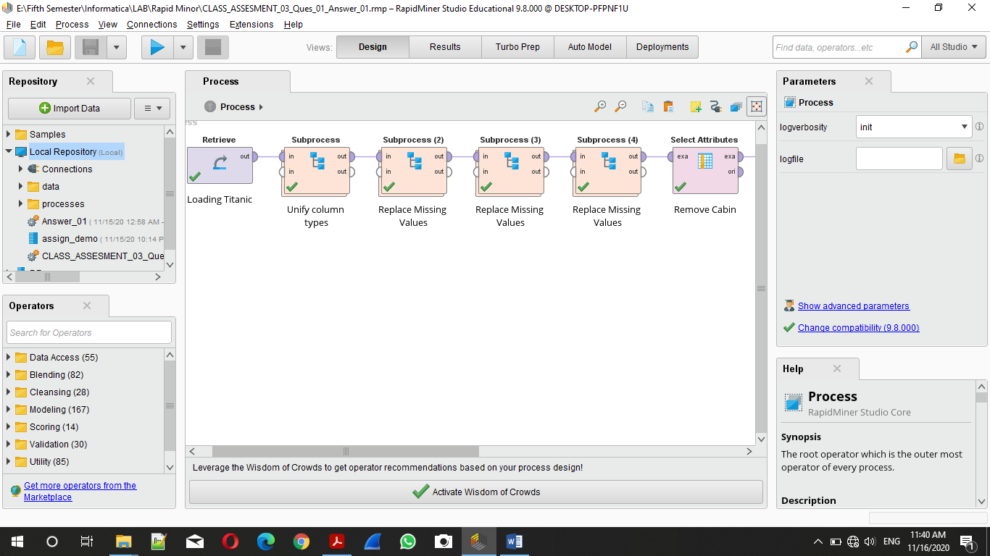

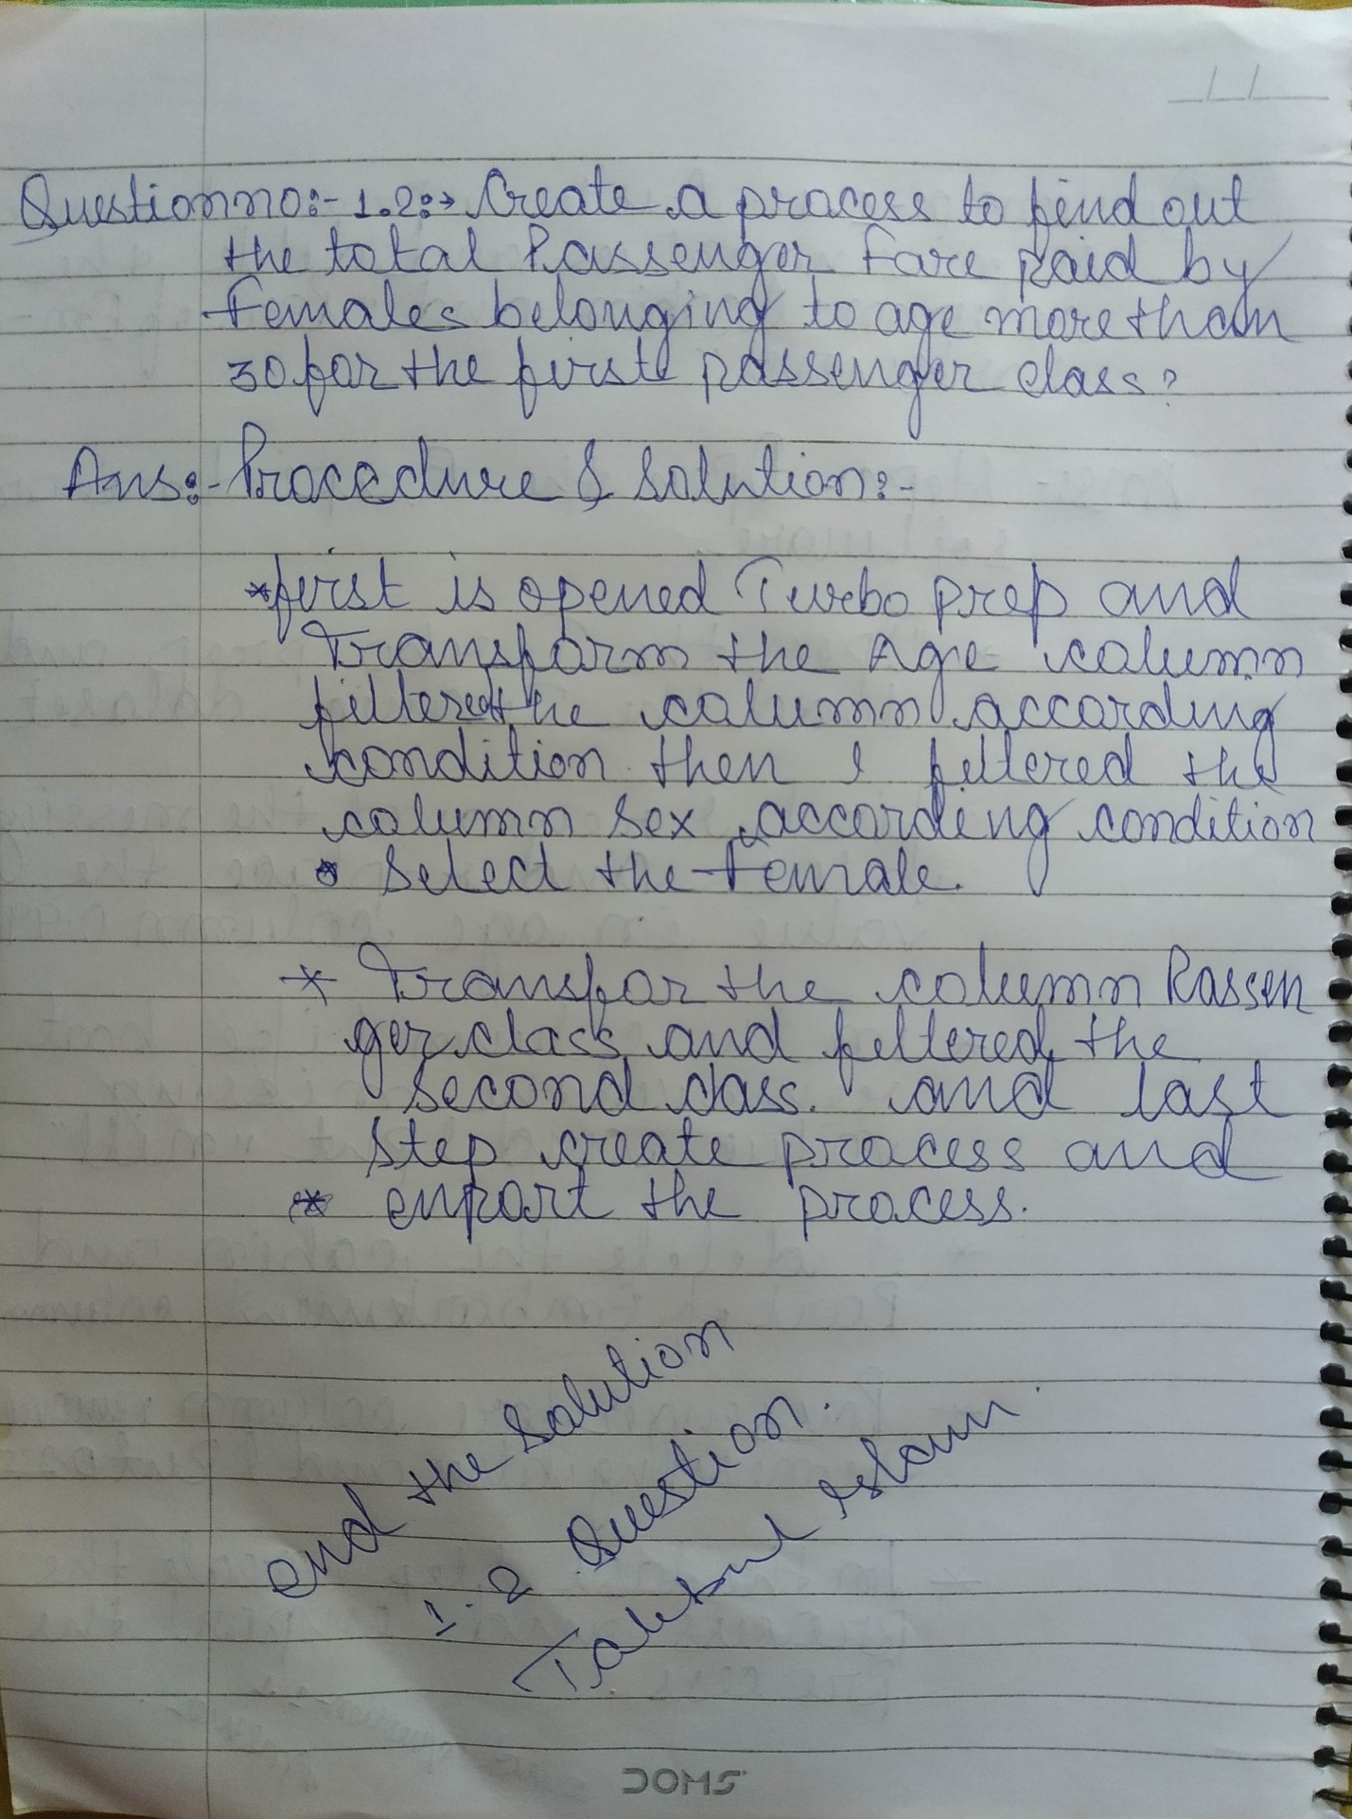

1. Filter the age Column According to Condition age > 30.

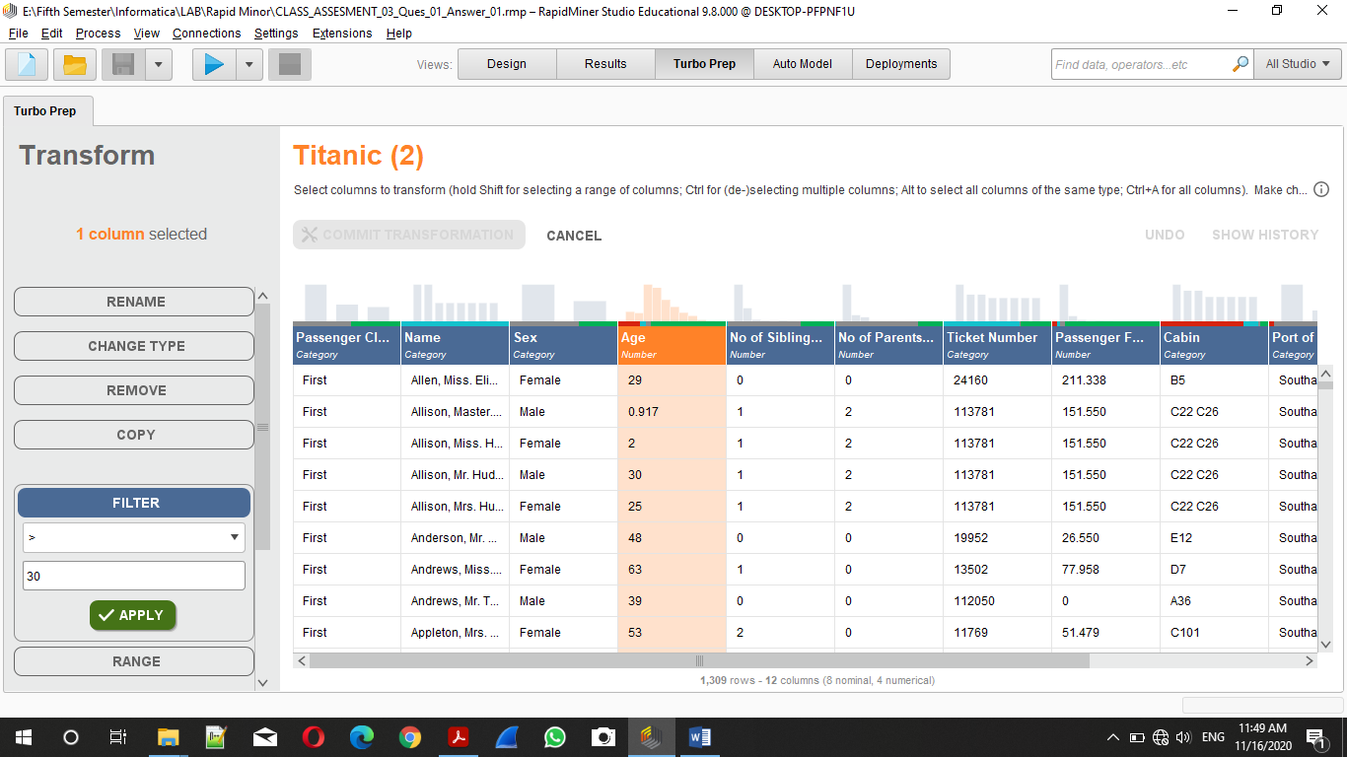

1. Filter Column Sex According to Condition Sex == Female.

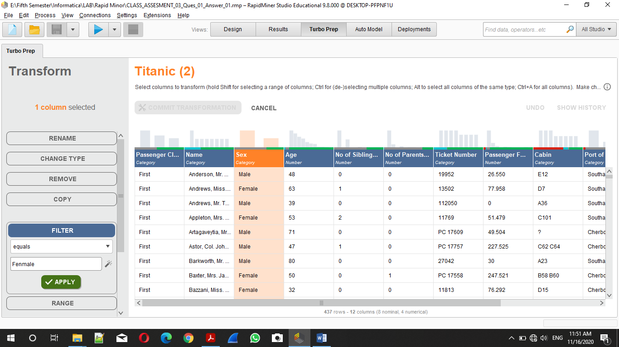

1. Filter Column Sex According to Condition Passenger Class == “Second”.

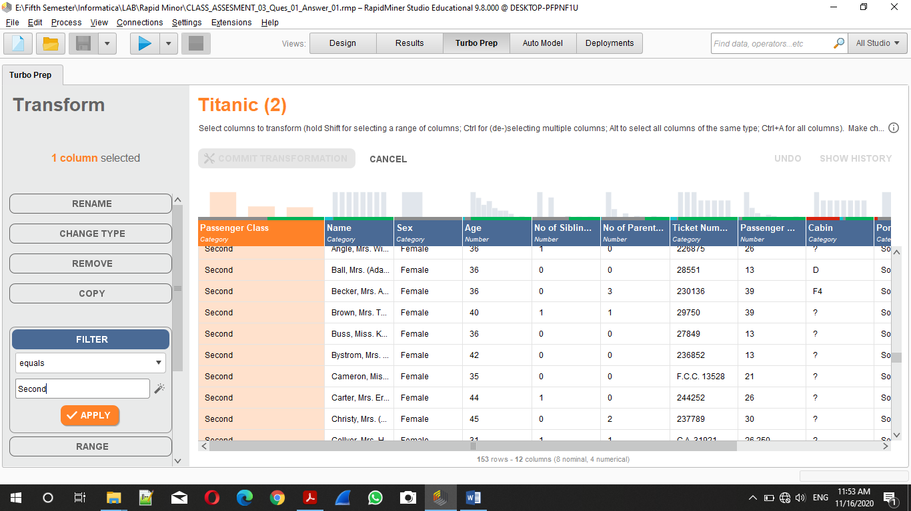

1. Use Aggregate Function for the Total sum of passenger Fare

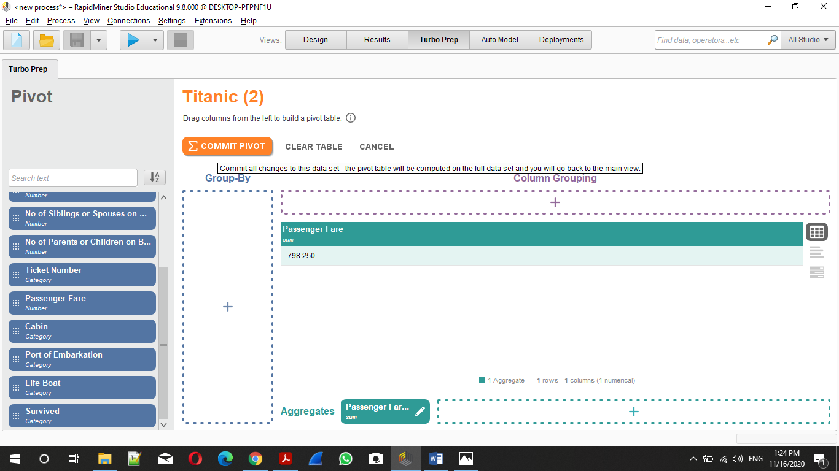

1. Final Design.

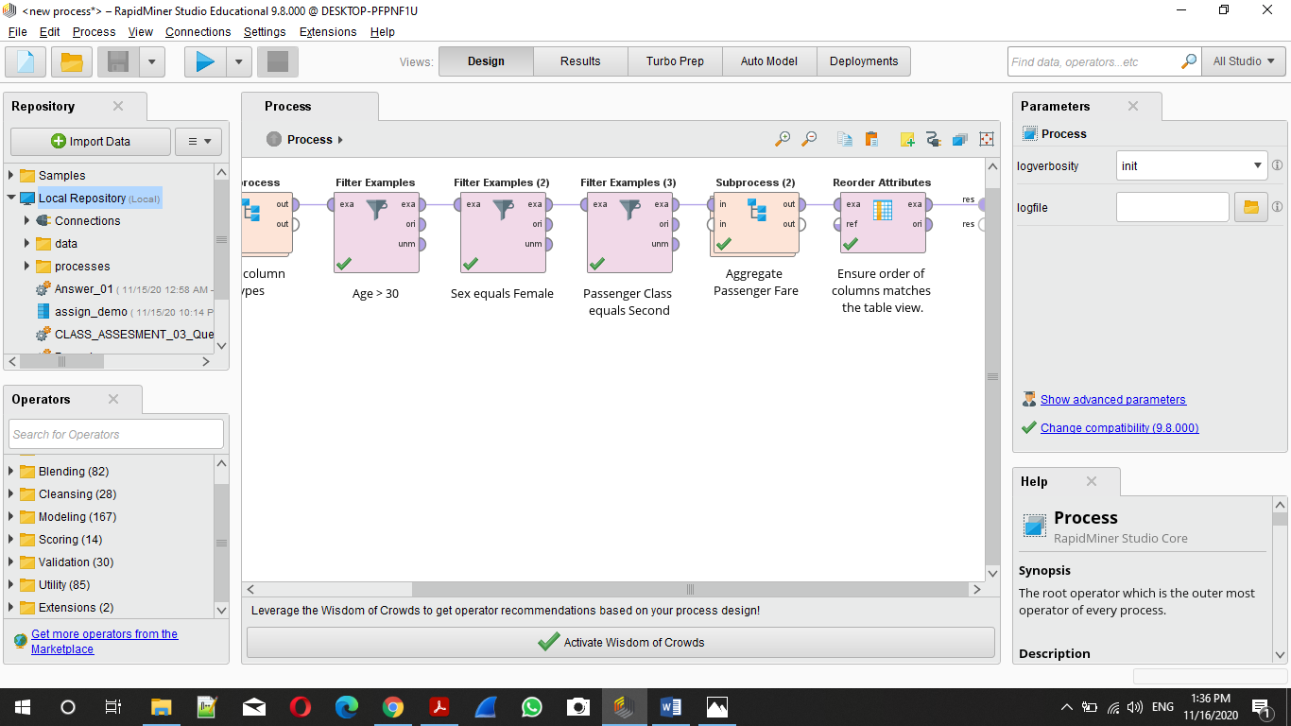

1. Output :-

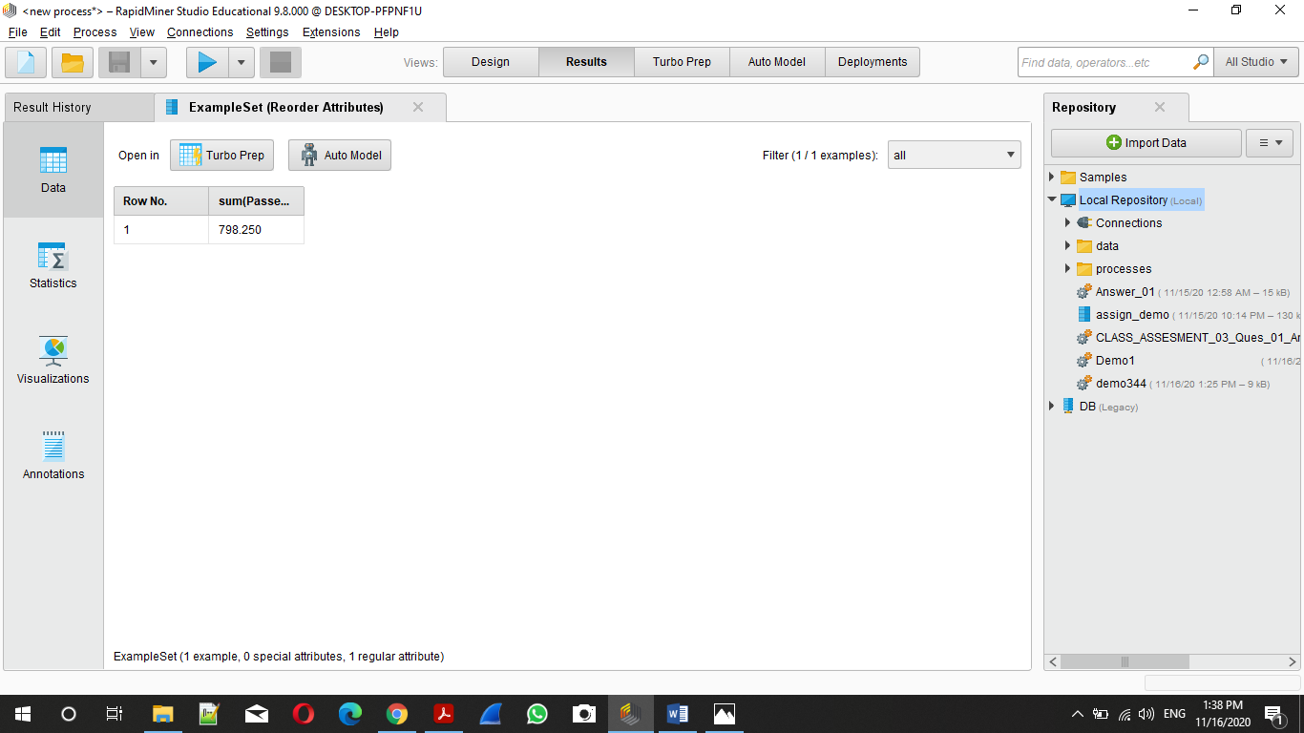

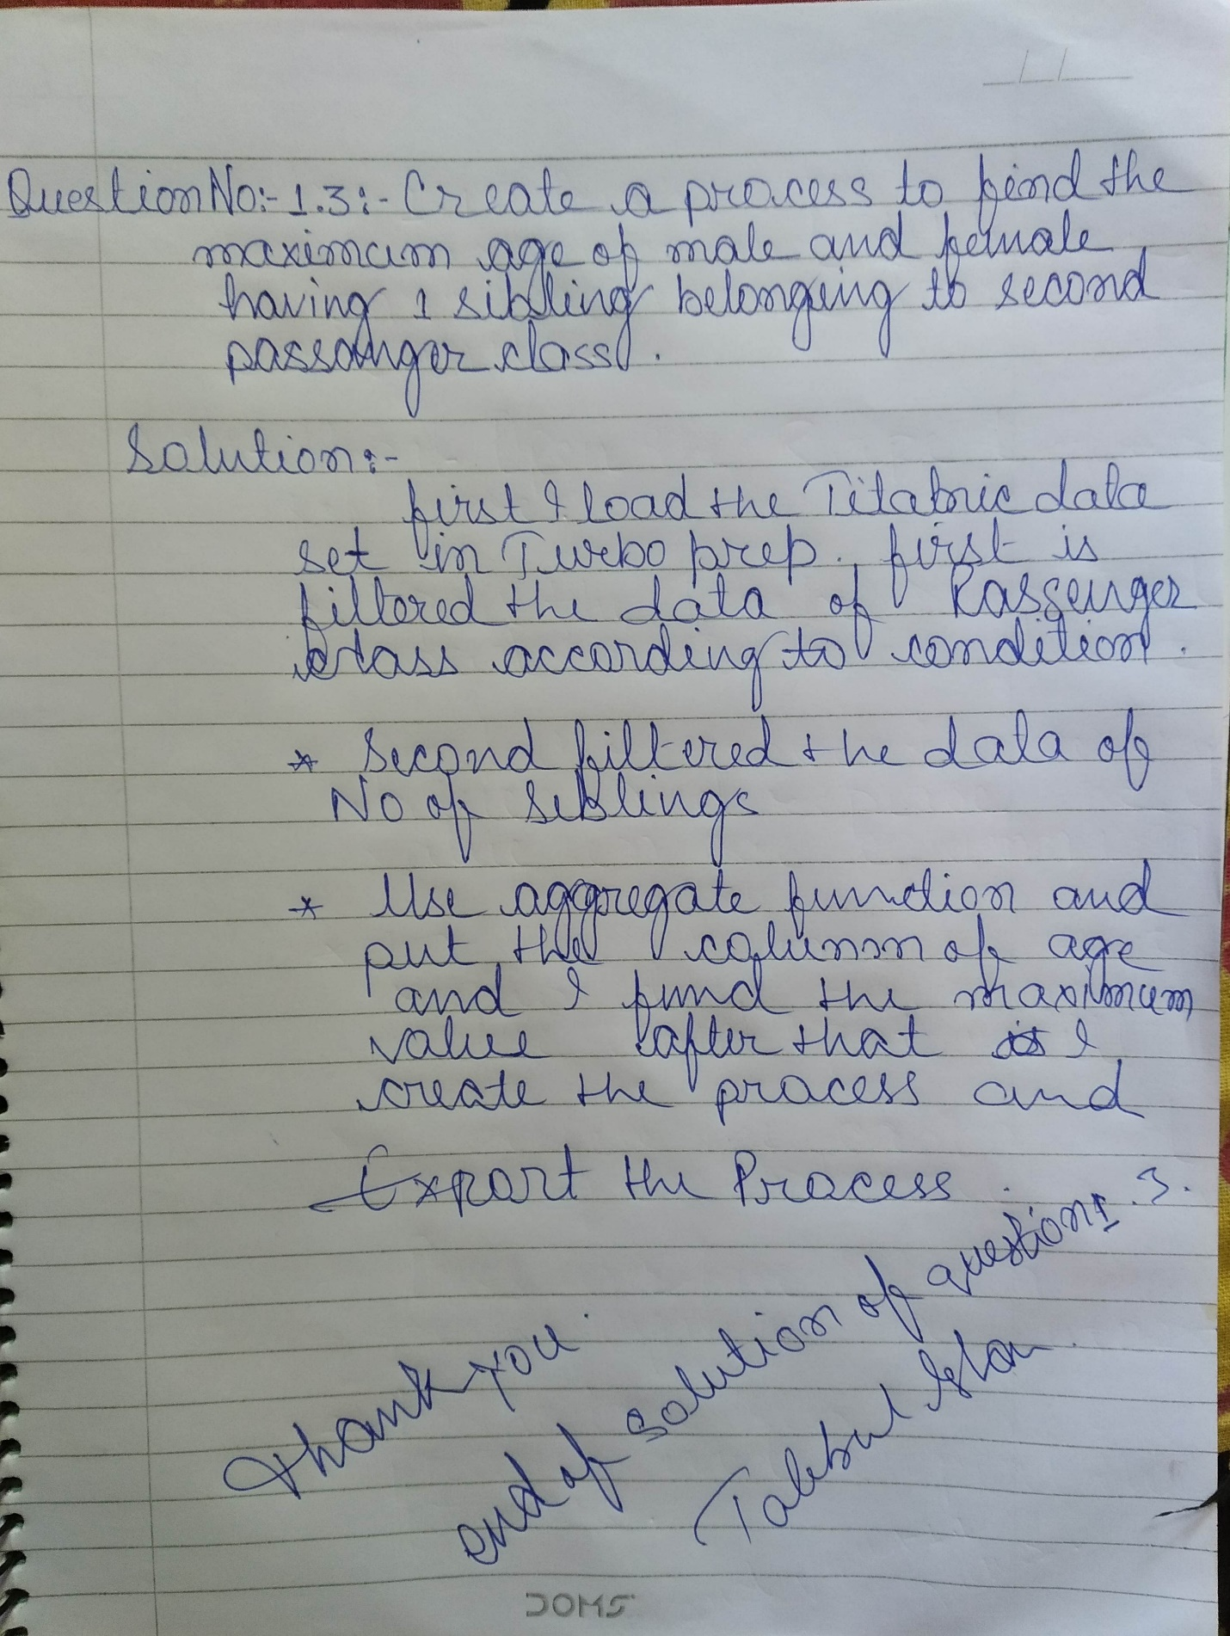

1. Filter Column No of Siblings According to Condition, No of Siblings == 1.

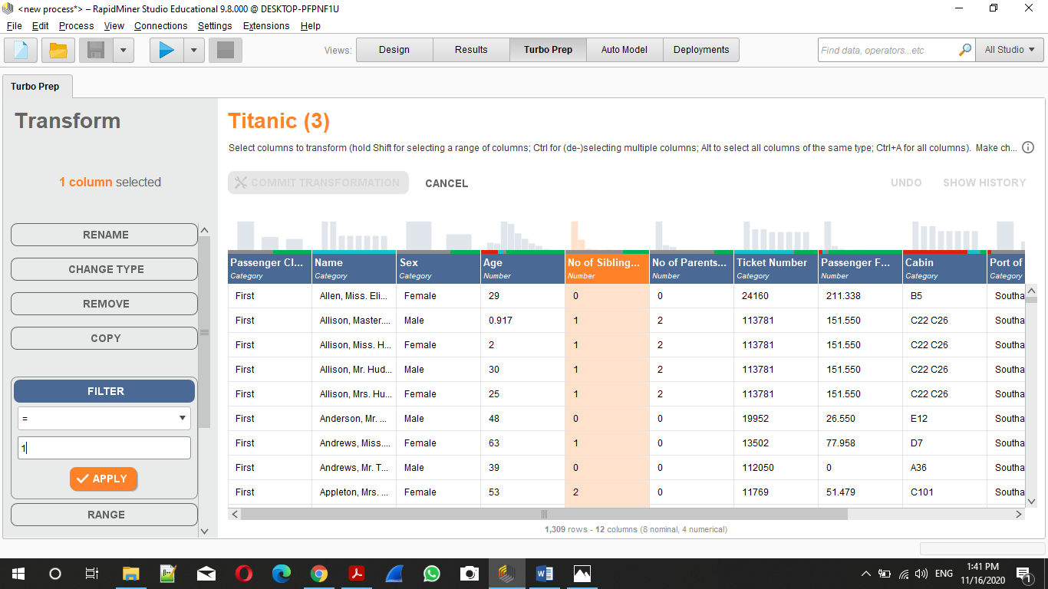

1. Filter Column Passenger Class == “second” According to Condition.

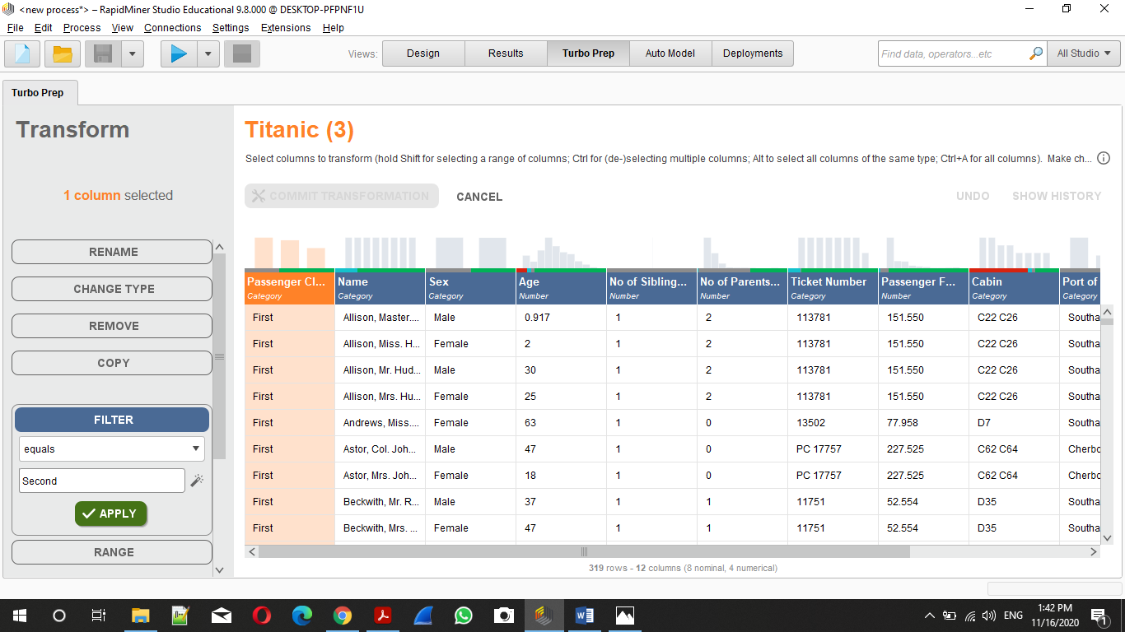

1. Maximum age of Male and Female .

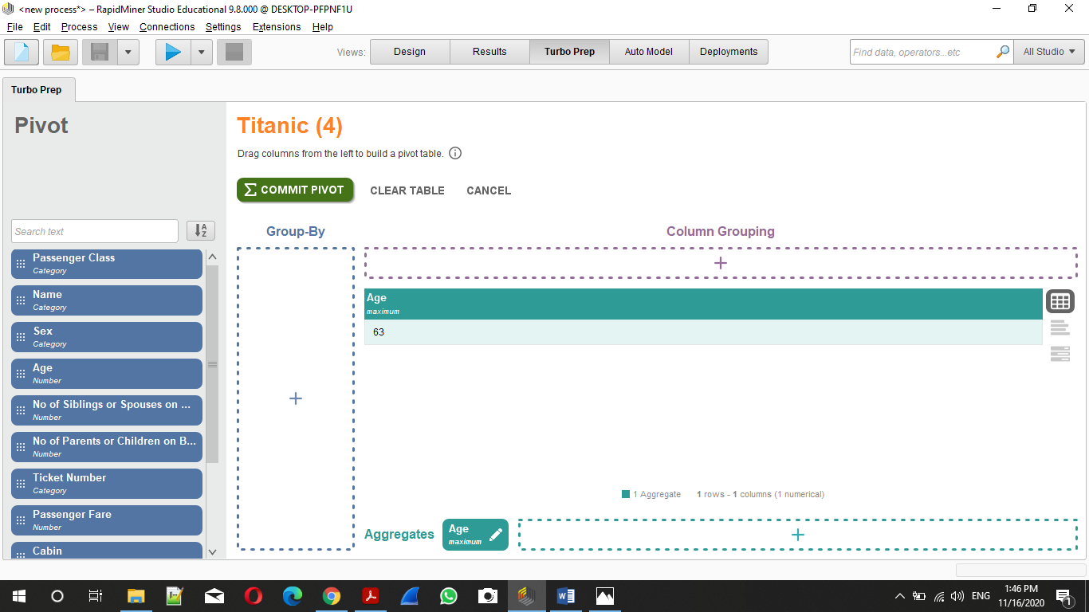

1. Final Design.

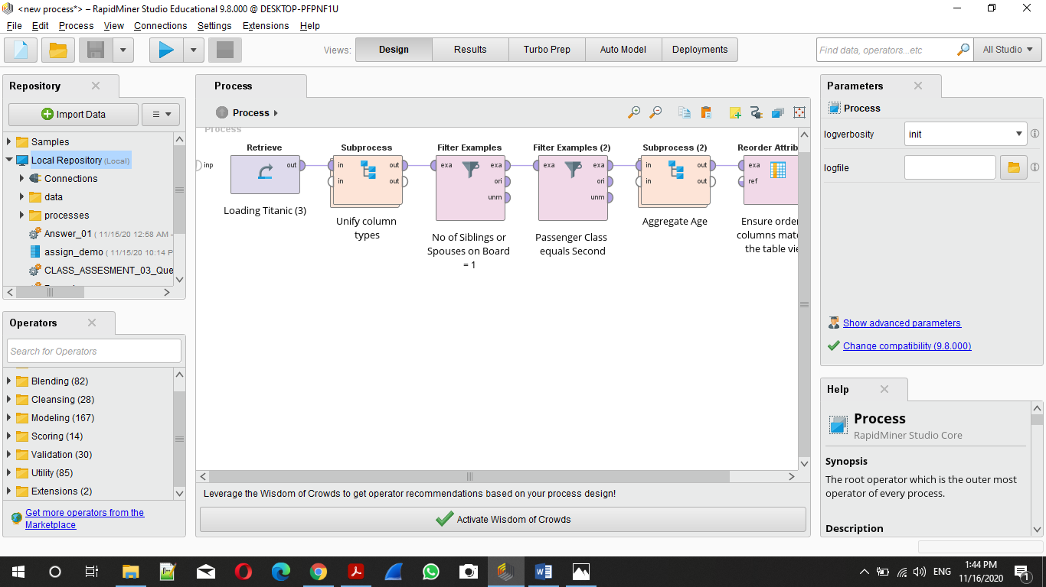

1. Output :-

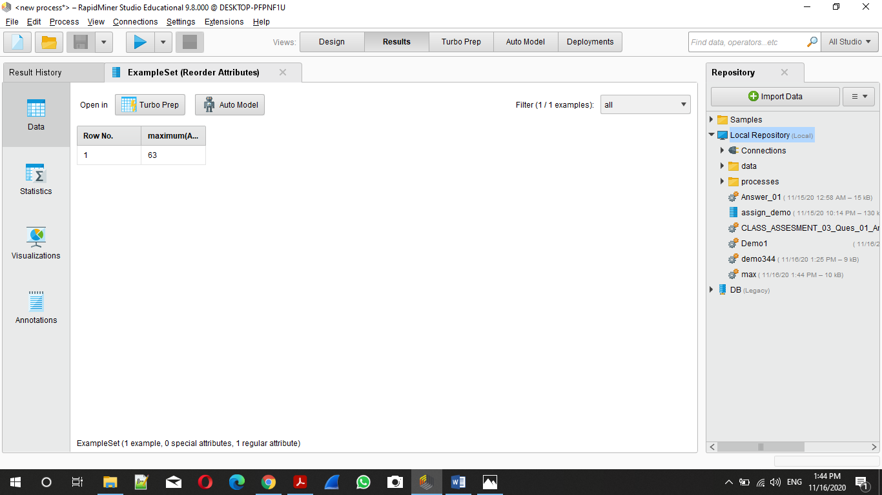

End Solution Of Question No 01

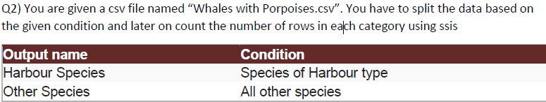

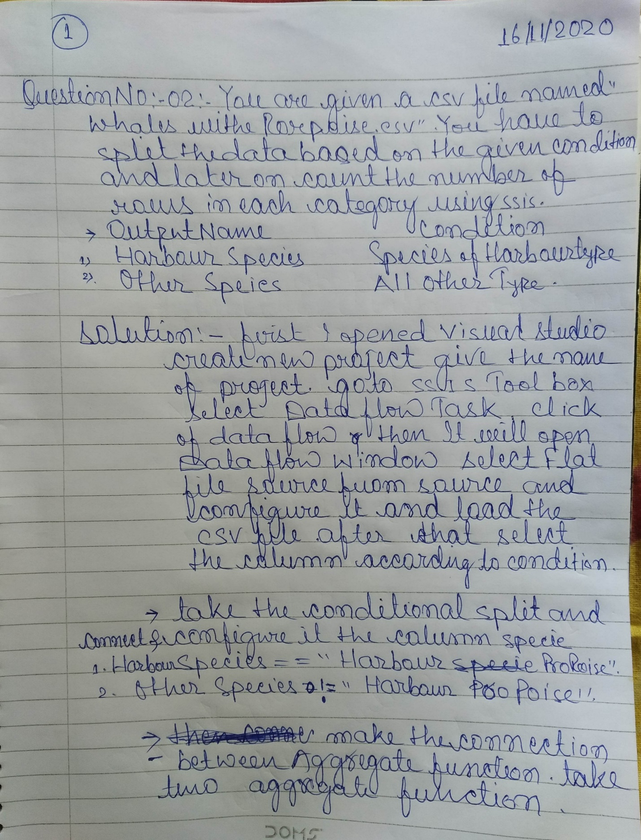

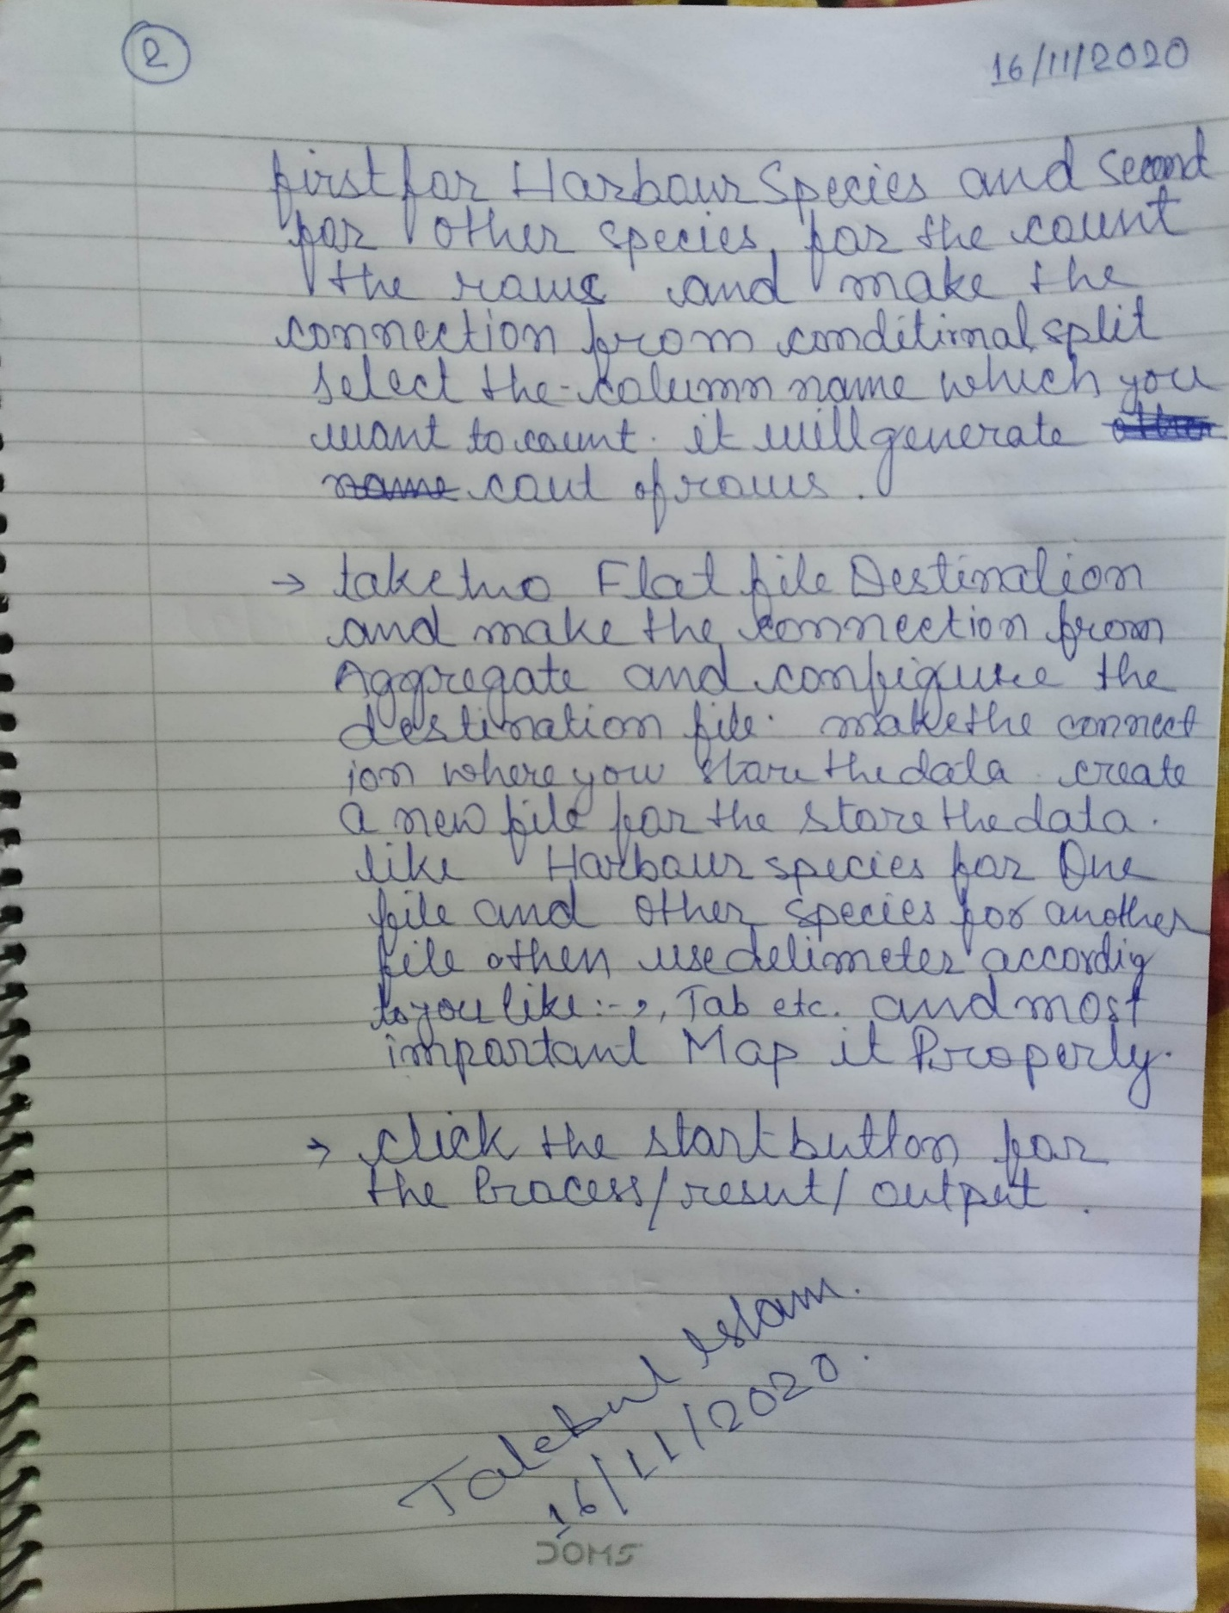

1. Opened visual Stdio

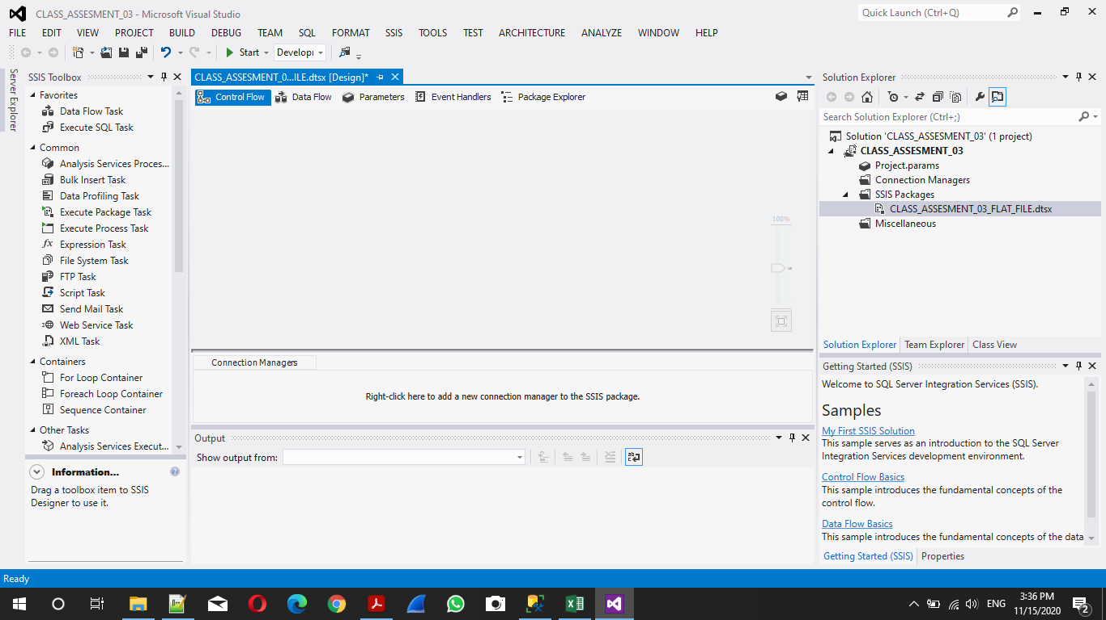

1. Select Data Flow Task From SSIS Toolbox

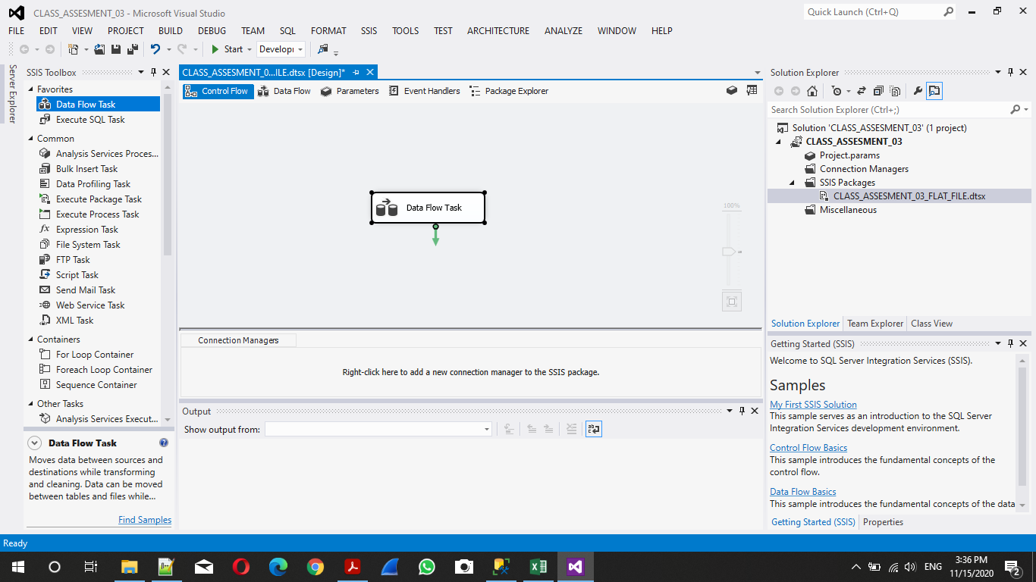

1. Select All The Required Tool From SSIS Toolbox. Like: - Source file, Conditional Split, Aggregate Tool, Destination File.

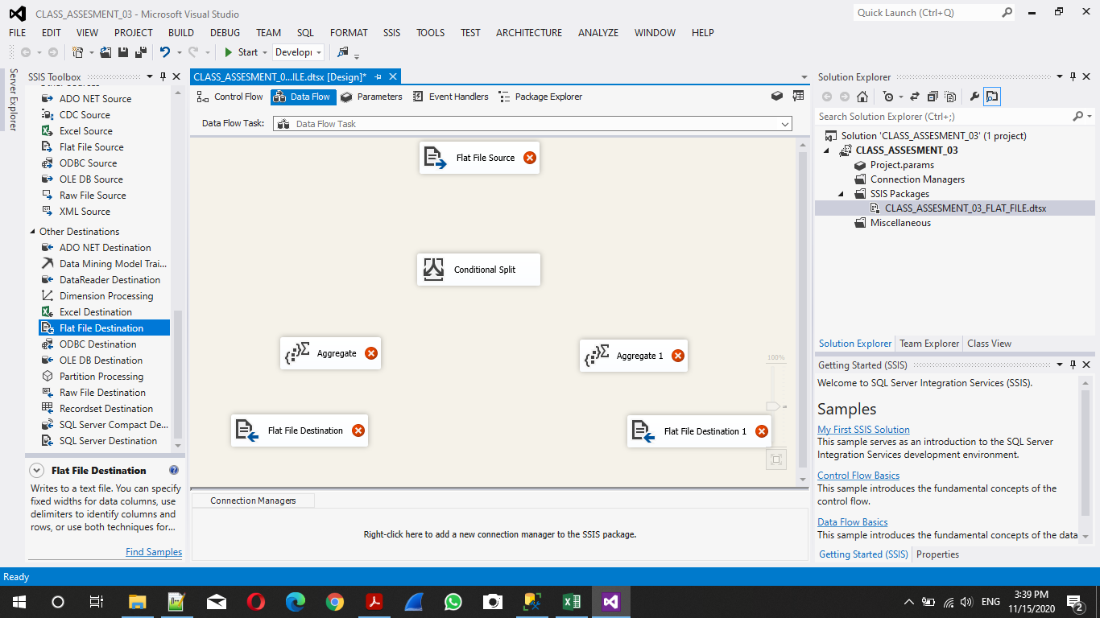

1. Configure Source Flat File.

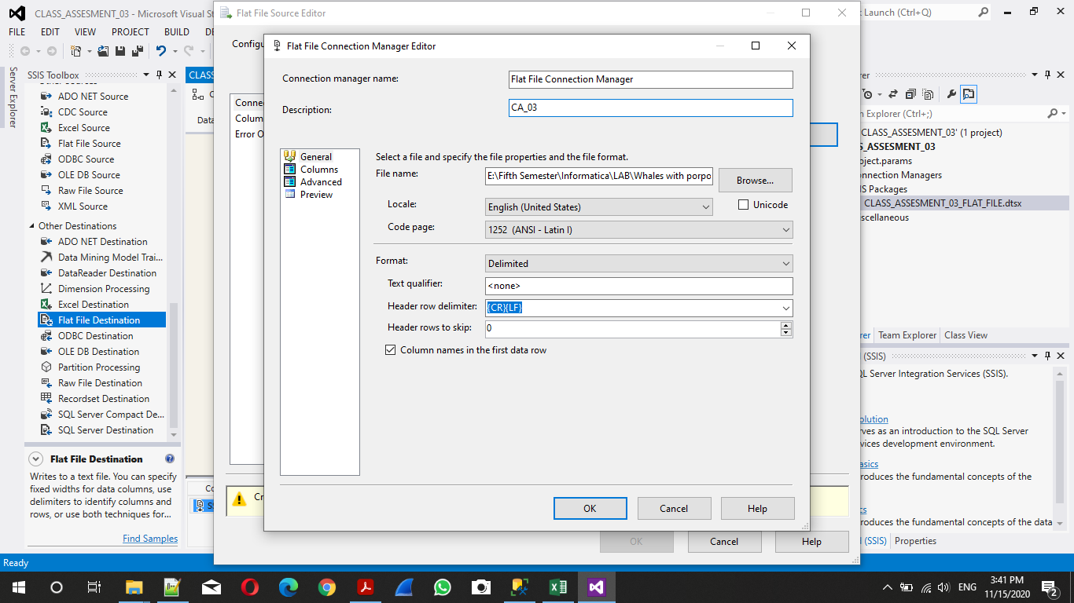

1. Configure Conditional Split According to Two Condition.

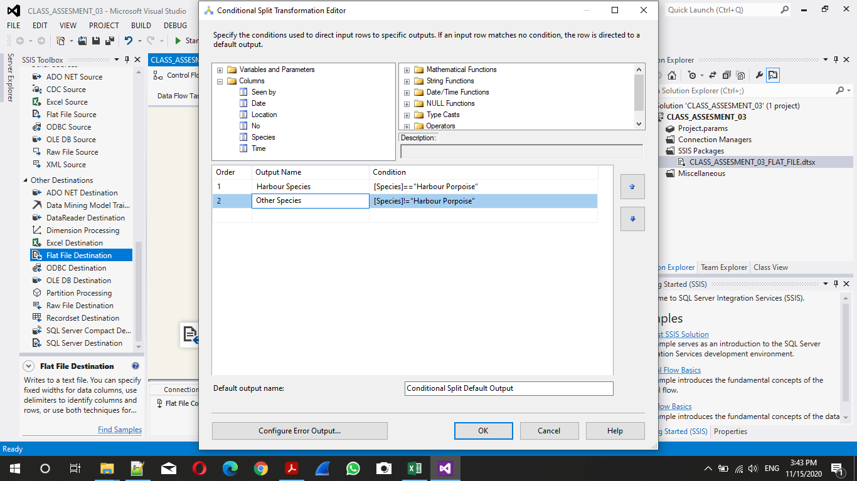

1. Connection of Harbour Species Aggregate Function Tool For rows count.

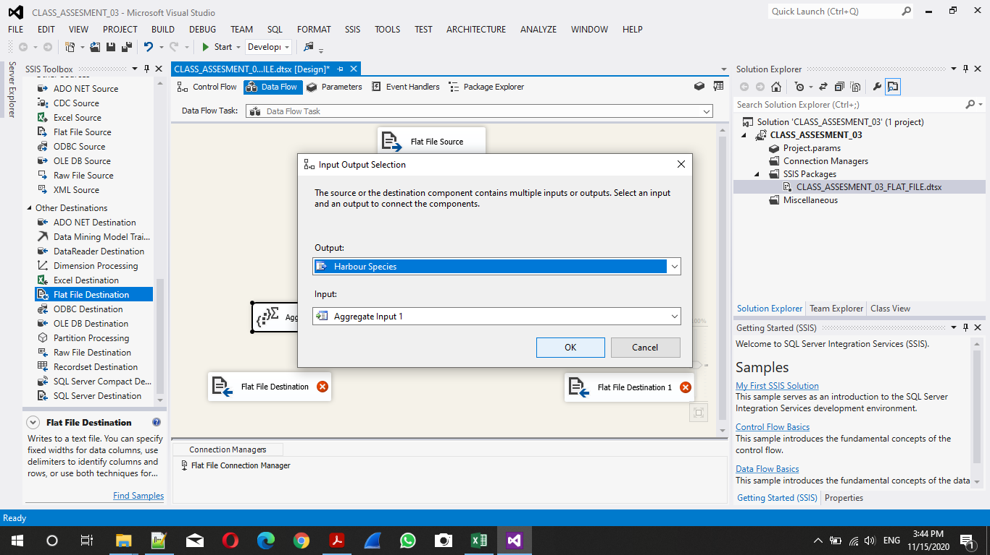

1. Connection of Other Species Aggregate Function Tool for Row Count.

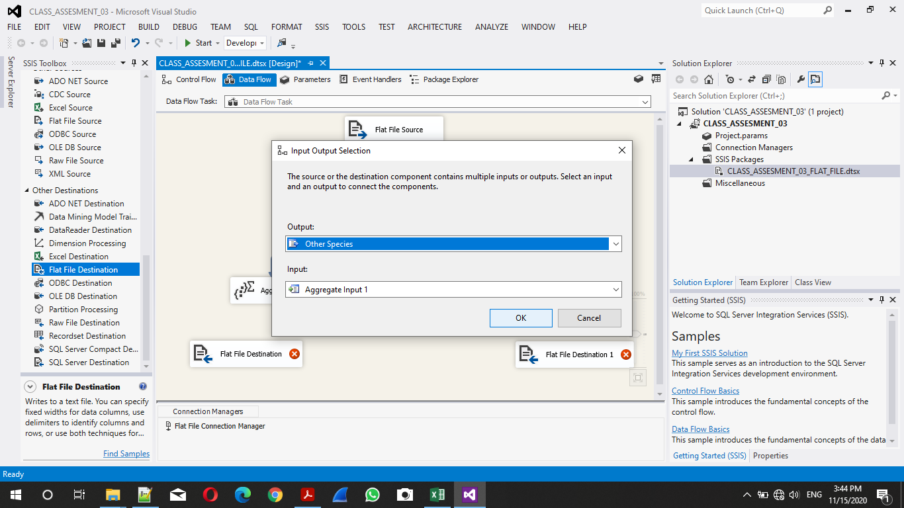

1. Configure Aggregate Function.

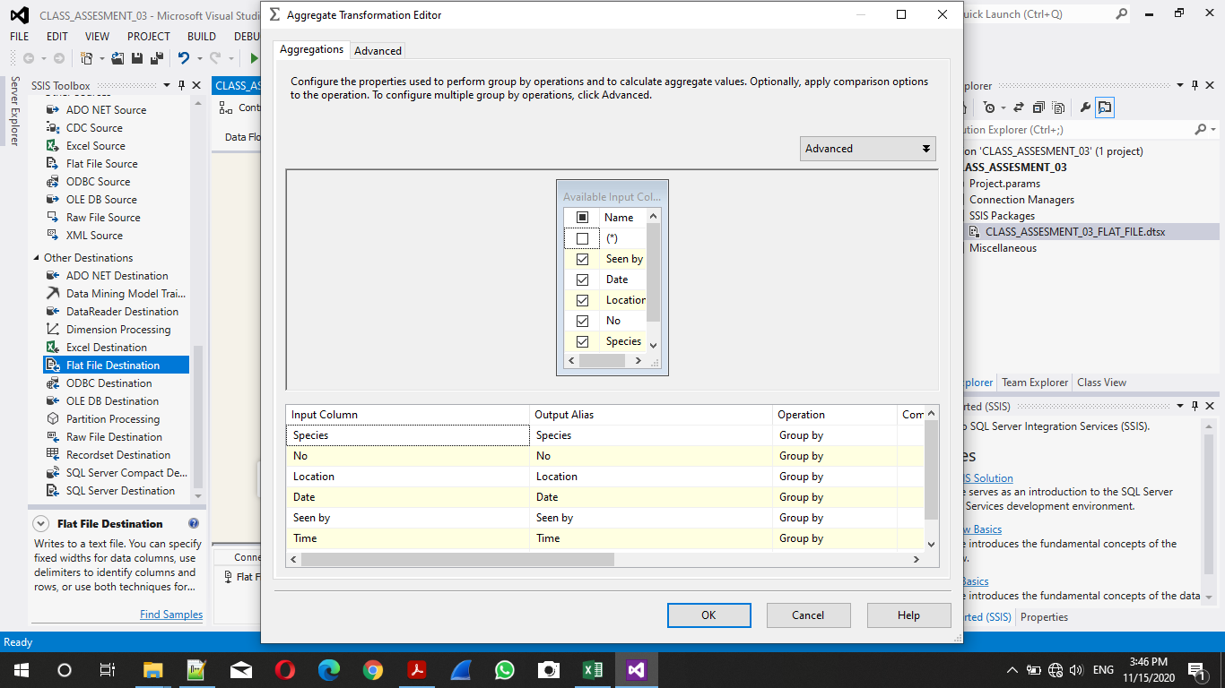

1. Mapping of flat File to destination Flat file.

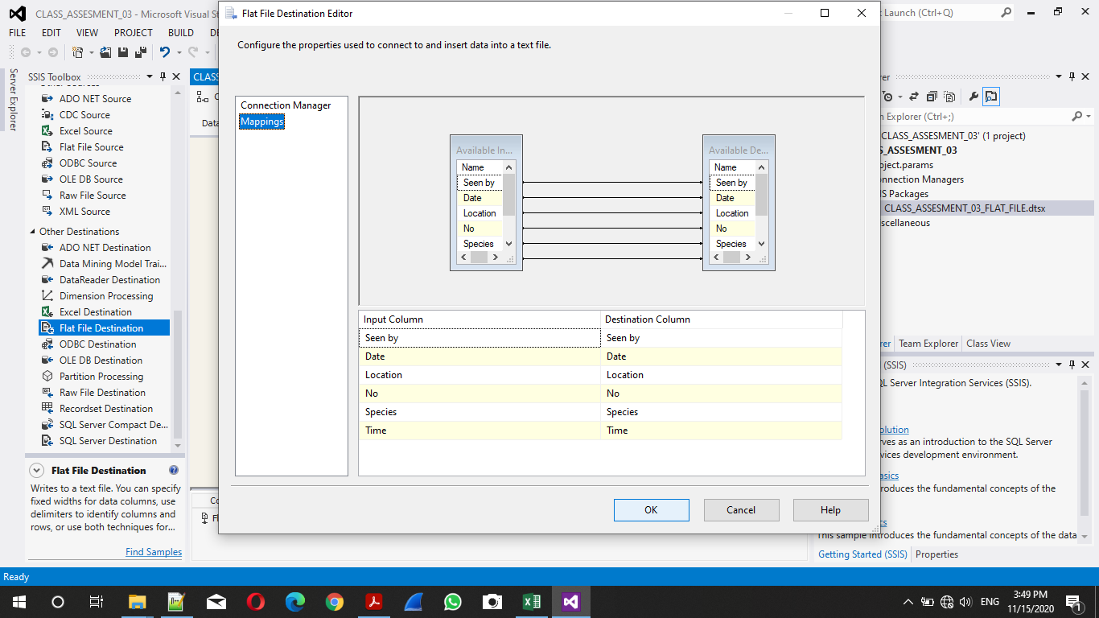

1. Final Data flow Design

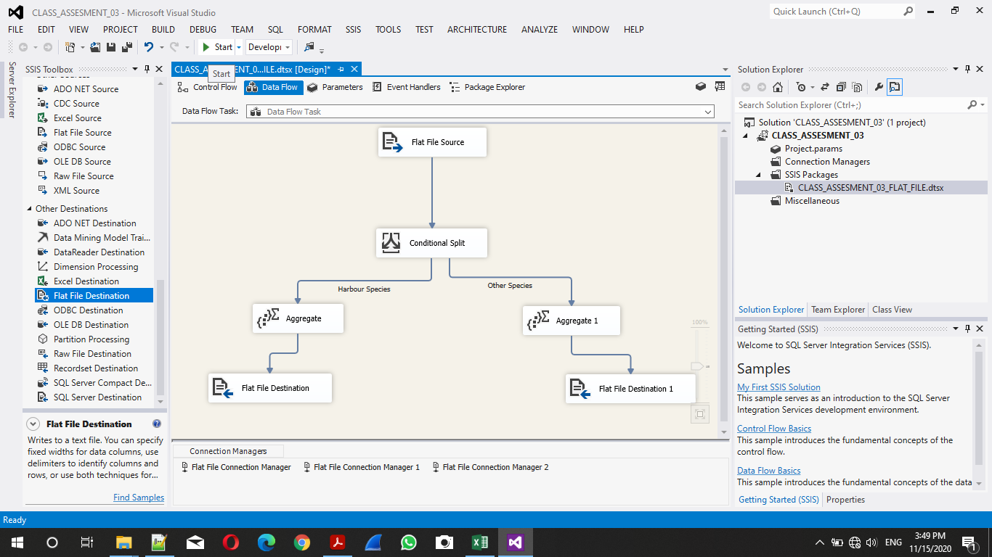

1. Output Window.

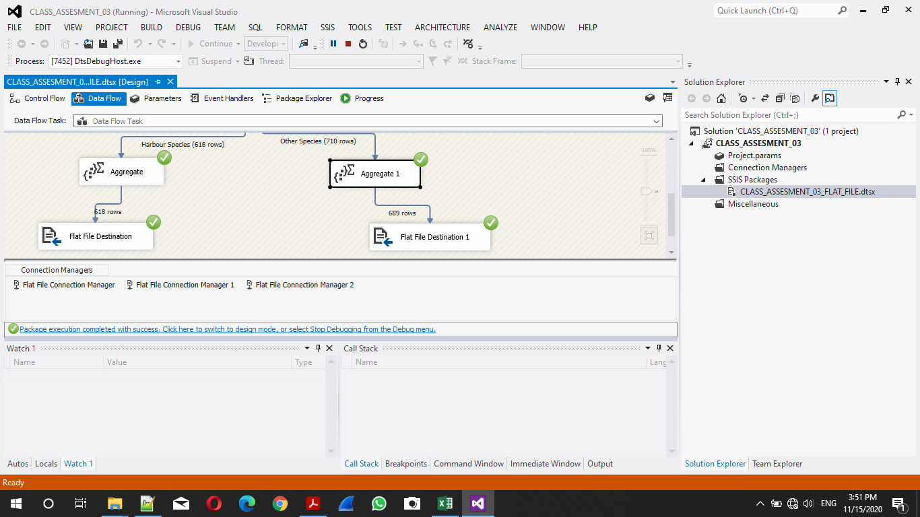

1. Execution Result.

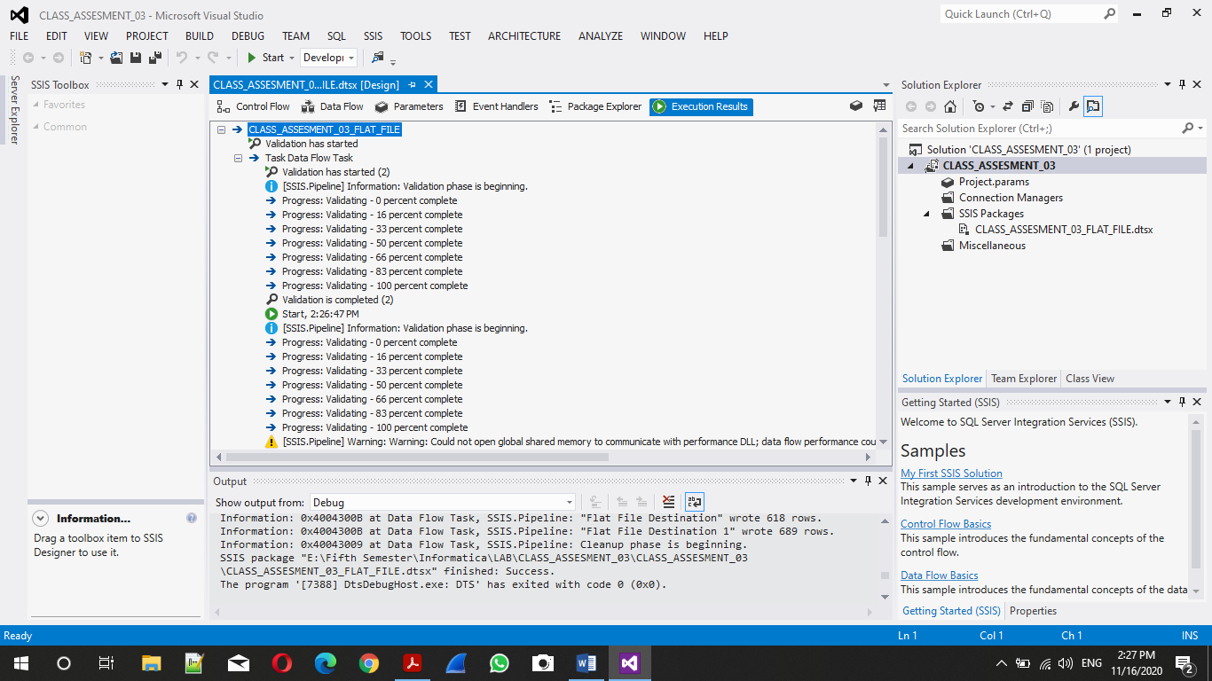

---------------------------+++THANK YOU MA’AM+++------------------------------